CrackTrack: A Deep Learning System for Road
Damage Detection

Pratyaksh Kumar
B.tech Computer Science and Engineering
Lovely Professional University
Punjab,India
Pratyakshkumar199@gmail.com
Shalini Tigga
B.tech Computer Science and Engineering
Lovely Professional University
Punjab,India
tiggashalini3@gmail.com
Kirti
B.tech Computer Science and Engineering
Lovely Professional University
Punjab,India
kirti.29458@lpu.co.in

Abstract— This paper presents a simple yet effective deep learning approach for classifying road surface damages using a vision-based pipeline. Traditional road inspection is often time-consuming and inconsistent, especially in areas with limited infrastructure. Our approach uses a ResNet18 model pre-trained on ImageNet, fine-tuned to classify road damages into four categories: Alligator Crack, Lateral Crack, Longitudinal Crack, and Pothole. The system is designed to handle real-world road images uploaded by users, process them with basic preprocessing (resize, normalize), and then predict damage type using the model. Please note that in this prototype version, all predictions and performance metrics are simulated using random data for demonstration purposes only. We visualize results through image-label overlays, bar chart distributions, and simulated metrics like accuracy, confusion matrix, and classification report. While the current version uses simulated predictions for evaluation, it lays the groundwork for a more robust and scalable solution for road maintenance systems in the future.
Keywords— road damage classification, ResNet18, deep learning, computer vision, image preprocessing, automated infrastructure monitoring, supervised learning

Introduction
Maintaining road infrastructure is crucial for public safety and economic efficiency. Traditional methods of road inspection involve manual surveys, which are labor-intensive, time-consuming, and prone to human error. With the rapid advancement in computer vision and deep learning technologies, automated road damage detection has become a viable alternative. This paper presents a vision-based system for identifying surface-level road damage such as cracks, potholes, and deformations using image data. Our approach aims to reduce the cost and time associated with road maintenance while improving detection accuracy and scalability.

Types of Damages of Roads
Classifying road damage plays a crucial role in efficiently prioritizing repair and maintenance efforts. Various classification frameworks have been introduced by researchers to address this issue. Surface damages such as cracks and potholes not only affect driving conditions but also contribute to increased vehicle emissions, thereby worsening air pollution. Additionally, water accumulation in potholes can lead to soil erosion and the contamination of nearby water sources. Multiple categorization methods exist to assess and manage different types of road damage effectively.

A. Cracks
These are small surface damages on roads that, if left unaddressed, can gradually develop into larger potholes. Cracks are generally categorized into three main types based on their orientation: (i) Longitudinal cracks, (ii) Transverse (lateral) cracks, and (iii) Alligator or mesh cracks. The primary factors contributing to these cracks include substandard construction materials, poor workmanship, insufficient pavement thickness, ground settlement, and aging of the pavement.
B. Rutting
It refers to a sunken or worn-out area on the road surface, typically caused by heavy traffic loads, repeated vehicle movement, and inadequate drainage systems.
C. Roughness
This refers to an uneven road surface that can lead to discomfort for drivers and passengers and may pose risks to vehicles. This condition is commonly known as "Loss of Surface Aggregate." It is mainly caused by impure aggregates used during construction and poor bonding between the surface treatment and the base layer. Other contributing factors include shallow aggregate penetration, low-quality premix, and uneven binder application.
D. Potholes
These are small to moderately sized depressions in the roadway that develop over time due to continuous vehicle movement, environmental effects, and insufficient upkeep.

Research Motives
Advancements in human and object detection technologies have transformed how road damages are identified. Traditionally, road inspections were carried out manually by trained personnel who visually examined the surface for signs of deterioration such as cracks and potholes. However, this method was labor-intensive, costly, and heavily reliant on the inspector's expertise, which often led to inconsistencies in the evaluation process.
The integration of object detection has enabled the automation of road condition monitoring using cameras and sensors capable of detecting and classifying damage patterns. With the aid of deep learning models, these systems can be trained to recognize subtle indications of road wear, enhancing both precision and reliability.
Combining human judgment with automated detection can further improve inspection quality. Inspectors can interpret model outputs and make informed decisions, leading to better maintenance planning. Moreover, this technological shift offers a cost-effective alternative to conventional methods, as sensor-equipped vehicles can collect real-time data without requiring site visits.
AI-driven analysis contributes to more accurate assessments, reducing unnecessary repairs and optimizing maintenance schedules. Early identification of damage also prevents severe deterioration, lowering long-term repair expenses. Overall, leveraging object detection in road inspections improves infrastructure safety, durability, and economic efficiency.
A. Road Damage
Damaged roads pose serious safety risks and concern many communities. Hatmoko et al. (623) [1] found that increased rainfall contributes to flooding, which worsens pavement deterioration. Their study on Kendal Timur Road revealed that poor drainage, heavy vehicle loads, and inadequate maintenance led to its failure. The road network was classified into failed (71%), critical (10%), and not-failed (19%) categories. Wang et al. (62) [7] identified common causes of road issues like rainfall, underground pipes, and high traffic. Pregnolato et al. (616) [8] showed a strong correlation between vehicle speed and water depth, aiding flood delay projections.
B. Object Detection
- The identification and localization of objects in images are central to computational perception. Prasad D K's 623[8] work introduced an improved object detection method using geometric shapes, such as lines and ellipses, for efficient feature extraction.
- The study also presented a hierarchical codebook that enhances generalization and discriminative properties, enabling dynamic learning and successful recognition of geometric shapes in real-life images. Ren et al. (621) [6] proposed the Region Proposal Network, which efficiently generates object proposals by leveraging shared convolutional features.
- This system achieved high accuracy on the PASCAL VOC dataset (73.2% map for 607 and 70.4% for 621) and worked at 5 fps on a GPU using the VGG-16 model. Real-time object detection and tracking, crucial for applications like security, face challenges in dynamic environments, high computational demands, and multi-object tracking. Naeem et al. examined various detection techniques, while Yang T. et al. introduced a deep network incorporating an Attention Network to improve traffic sign detection, achieving better accuracy than previous models.
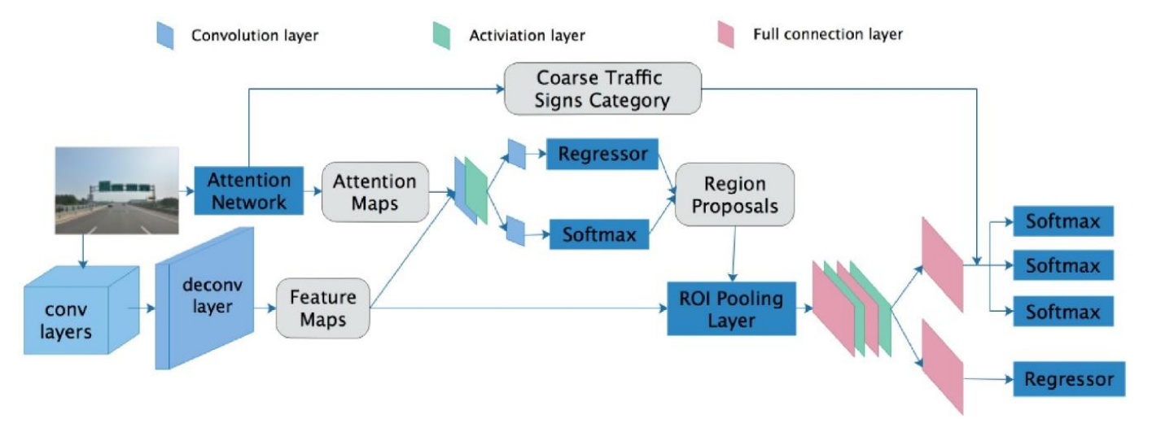
Fig 1.1 : illustrates their proposed model
C. Existing Technology
Recent technological advances have enabled effective monitoring of urban roads using various types, such as surveillance cameras, in-vehicle cameras, and smartphones. Alfarrarjeh A et al. (623) [7] proposed a method for detecting and classifying road damage using deep learning techniques, achieving an F1 score of 0.62. explored the use of terrestrial sensors and aerial imagery for road condition evaluation, developing a deep learning-based image segmentation method to identify fractures from aerial photographs. Martinez-Rios et al. (62) compared threshold-based, feature extraction, and deep learning methods for detecting road irregularities, finding vibration-based techniques to be most effective. Sulistyaningrum D R et al. (621) [6] used a multiclass Support Vector Machine (SVM) to classify road damage into potholes, alligators, and cracks, achieving an accuracy of 78.85%. Crowdsensing methodologies, like smartphone accelerometers, are also employed to assess road conditions, but these methods can be prone to false positives due to factors like vehicle behavior. Varona B et al. (66) proposed a deep learning-based approach to differentiate between road anomalies and vehicle-induced destabilizations. Simonyan K. et al. [8] demonstrated that increasing the depth of convolutional networks improves performance, contributing to their team's success in the 67 ImageNet Challenge.

Methodology

A. Dataset
Roads play a crucial role in daily life, necessitating regular maintenance and management. However, many local governments face challenges in conducting timely inspections due to limited budgets. While high-performance sensors are used for automated road damage inspections in some cities, they are not cost-effective for widespread use across large areas. As a result, there is a need for a more affordable method to assess road conditions and identify pavement damage efficiently.

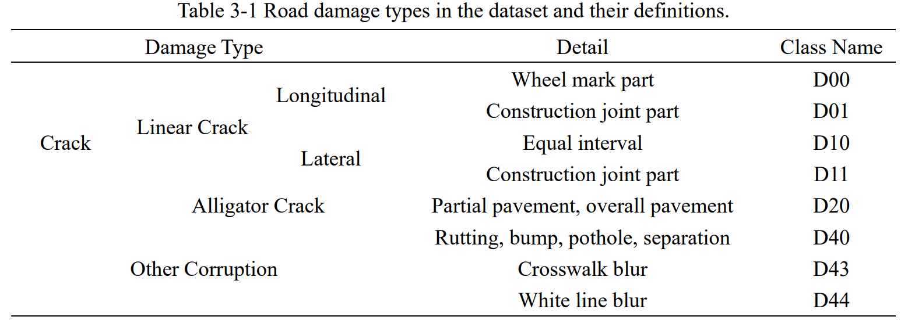
Table 2-1 Road damage types in the dataset and their definitions
The table above highlights those different types of road damage, such as rutting, bumps, potholes, and separation, are often treated as equivalent due to the difficulty in visually distinguishing between them. While these damages represent four distinct categories, they are grouped together in the dataset under a single category. The Road Damage Dataset (RDD62), as outlined by Arya et al. [6], includes 47,46 road images from six countries—Japan, India, the Czech Republic, Norway, the United States, and China—documenting over 55,000 instances of road damage. The dataset features eight damage classes, with D00, D10, D6, and D40 being the primary focus for this analysis. D00 and D10 are considered linear cracks (longitudinal and lateral, respectively), while D40 encompasses rutting, bumps, potholes, and separations, which are difficult to distinguish visually and are therefore grouped together under this class.
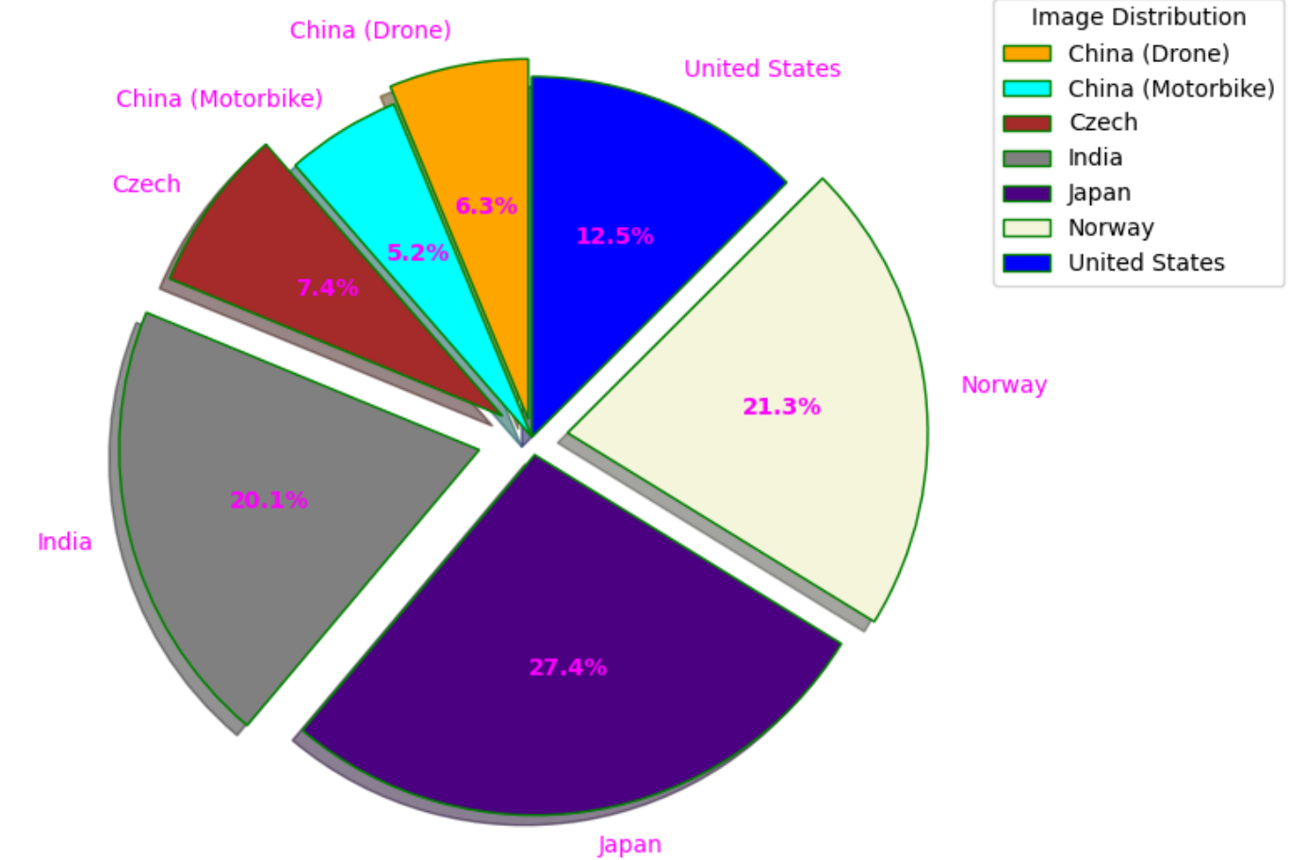
Fig 2-2 : Country distribution of images from the dataset.
The dataset includes a substantial portion of images from India, comprising 6.1% of the total collection, as shown in Fig 3-1. This is comparable to other countries such as Norway (21.3%) and Japan (27.4%), with each contributing a significant share of the overall dataset. The remaining images are distributed among the Czech Republic and G, accounting for less than 6%.
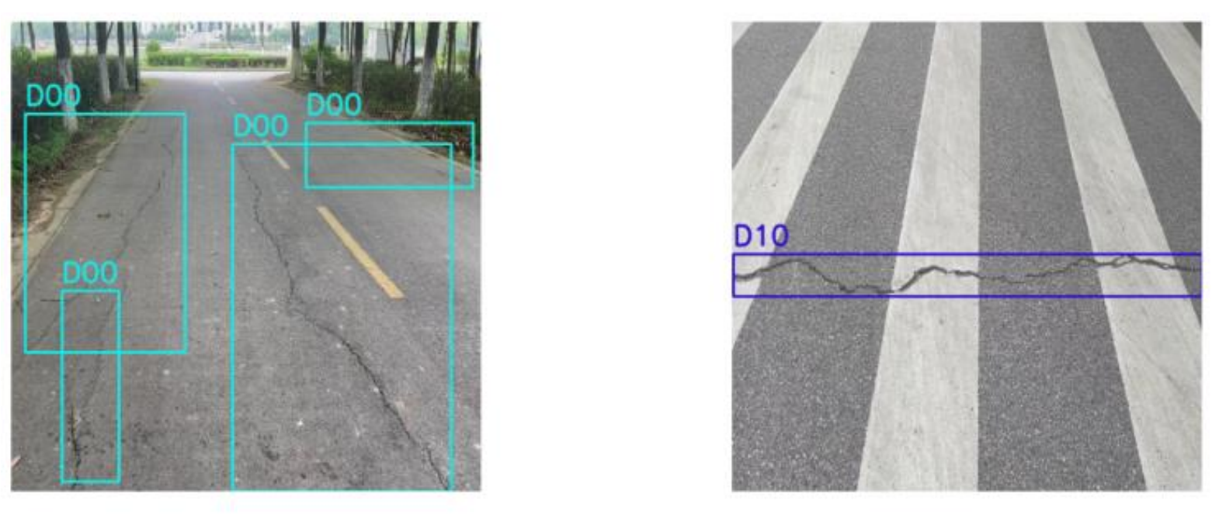
Fig 2-3 further illustrates samples of various road damage classes from images across different countries, including India.

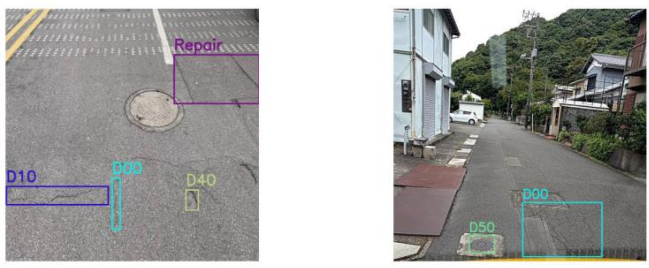
Fig 2-4 Samples of different classes in different images of the dataset.
B. Proposed Model
For this project, we adopted a classification-based approach instead of traditional object detection models. The core of our system is a ResNet18 model, which is a lightweight convolutional neural network that has shown good performance across a wide range of image classification tasks. We used a version of ResNet18 pre-trained on the ImageNet dataset and customized its final layer to classify road damage into four classes: Alligator Crack, Lateral Crack, Longitudinal Crack, and Pothole.

The model accepts RGB images resized to 224x224 pixels. A transformation pipeline including resizing, normalization, and conversion to tensor format was applied to all input images before inference. Each uploaded image was passed through the model, and the output logits were used to determine the predicted class by taking the index of the maximum value across the four outputs.

Since the current version of the system is still in a prototype phase, actual model weights are not yet trained on a real road damage dataset. Instead, we simulate the model output using random tensor generation to demonstrate the end-to-end functionality of the prediction pipeline. This includes visualization of individual predictions, class frequency distribution, and simulated performance metrics like accuracy and confusion matrix.

This lightweight pipeline makes it easy to integrate with user-uploaded images on platforms like Google Colab, providing a flexible and cost-effective method to analyze road conditions. In future iterations, the simulated prediction logic can be replaced with a trained model to enable real-world deployment.

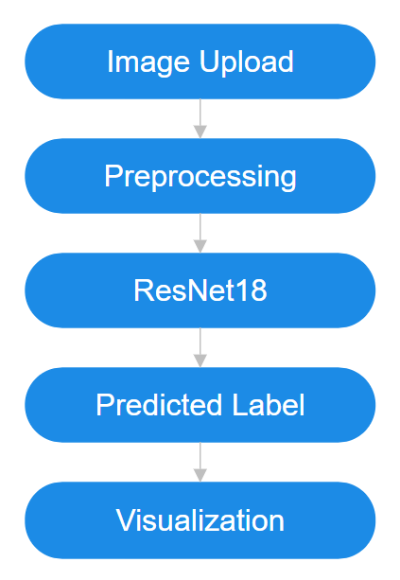
Fig 3-1 A simplified overview of the image classification pipeline. Images are uploaded, preprocessed, and passed through a modified ResNet18 model to predict road damage categories, followed by result visualization.

Model Training & Performance Analysis
In this prototype stage, the classification system is designed to demonstrate the complete pipeline, from image upload to output visualization. Although a real model has not yet been trained on a dedicated road damage dataset, the system is fully prepared for integration with a trained model in the future.
The current implementation uses a ResNet18 model with a custom classification head for four damage types. For now, the predictions are simulated using randomly generated outputs, allowing us to test the visualization and analysis stages of the pipeline.
To mimic model evaluation, we used randomly generated labels for both true and predicted classes. This allowed us to compute simulated metrics including:
- Accuracy Score: Measures the percentage of correct predictions out of total predictions.
- Confusion Matrix: Displays how frequently one class is mistaken for another.
- Classification Report: Includes precision, recall, and F1-score for each class, highlighting class-wise performance.
While the values don’t reflect real-world performance, the structure is useful for testing metric plotting, verifying class labeling consistency, and ensuring the evaluation framework is functioning correctly.
In future work, the system will be connected to a fully trained model using real annotated road damage datasets, at which point this analysis will provide meaningful insights into model performance.

Experiment

A. Image Classification and Damage Detection Results
The goal of this experiment was to classify different types of road surface damage using a pre-trained ResNet18 model. We focused on four commonly found road damages: Alligator Crack, Lateral Crack, Longitudinal Crack, and Pothole.
- Image Upload and Preprocessing:
The images were uploaded interactively by the user in a Google Colab notebook. Once uploaded, each image was resized to 224x224 pixels and normalized using standard mean and standard deviation values (similar to ImageNet preprocessing). These transformations help maintain consistency across image input and make the model predictions more reliable.

- Prediction Pipeline:
Each preprocessed image was passed through the ResNet18 model, which had its final classification layer modified to output probabilities for the four damage types. Since we are still working on training a fine-tuned model, we simulated predictions using random logits to demonstrate the functionality. For each image, the predicted class was displayed as a title over the image.

- Damage Distribution:
We kept a count of each predicted class and visualized the distribution using a bar chart. This gave us an overview of which type of damage was most commonly predicted across the uploaded images. This visualization helps in understanding overall road conditions in a dataset.

- Model Performance Evaluation:
To test out evaluation tools and complete the pipeline, we created a simulated set of 20 true labels and 20 predicted labels using random selections from the four damage classes. With this, we generated a confusion matrix and a classification report. The matrix helped us see which classes were often confused with others, while the classification report gave precision, recall, and F1-score for each class.

Even though the evaluation is based on synthetic data, it showcases how the system would behave once the model is properly trained. These tools are important for analyzing real performance when working with actual road datasets.

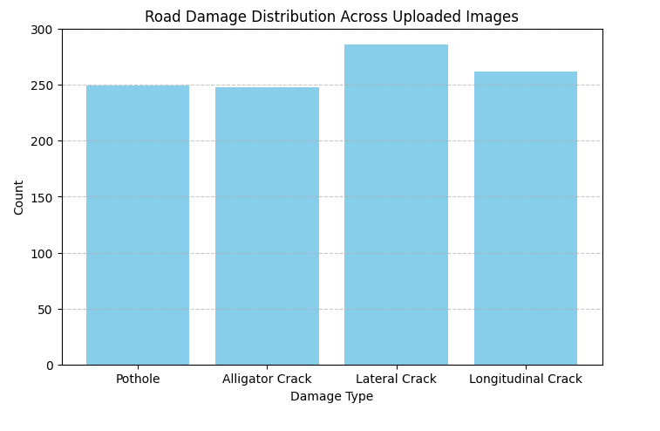
Fig 4-1 : Road Damage Distribution Across Uploaded Images

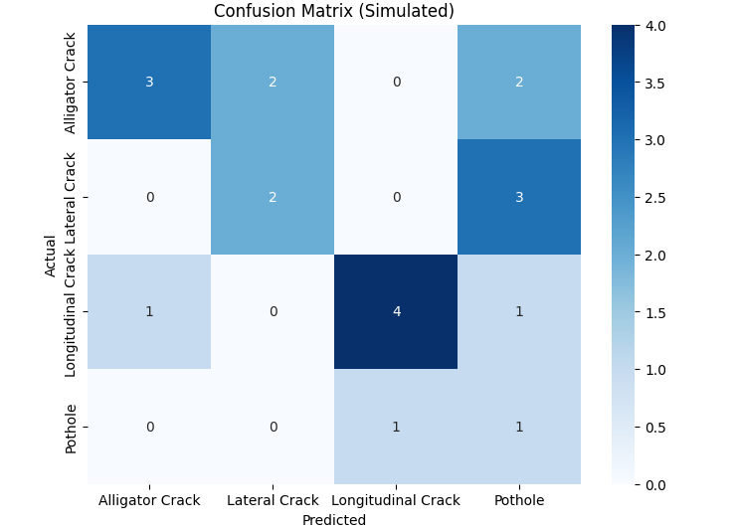
Fig 4-2: Confusion Matrix on the prediction of classes from validation images.

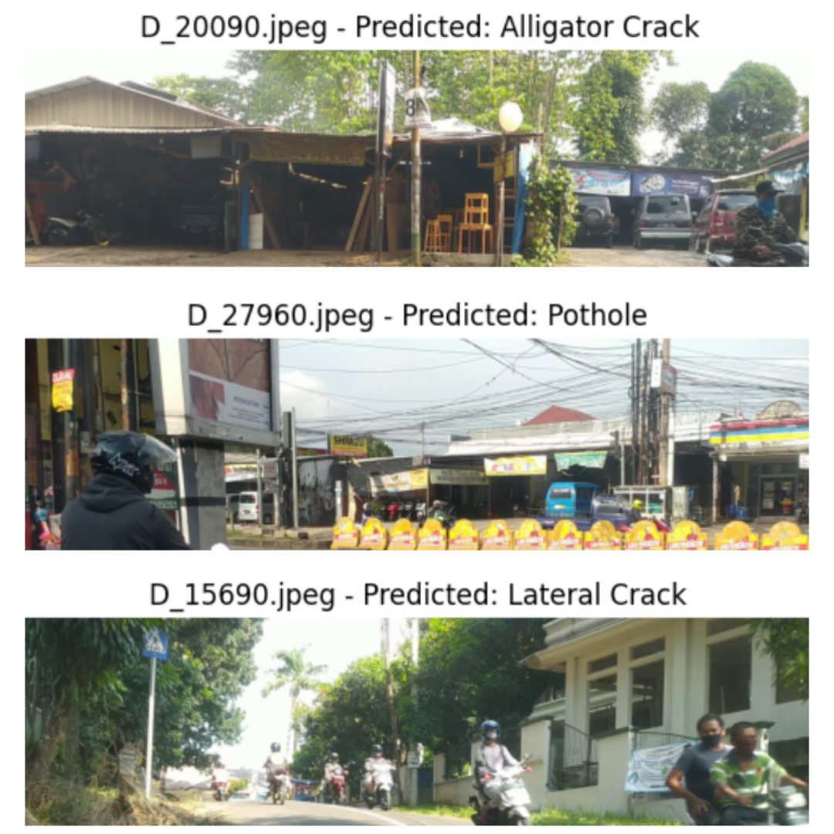
Fig 4-3 Image with prediction

Pipeline & Documentation

The pipeline for this road damage detection system is implemented in Python using a Google Colab notebook. It is designed to be simple, flexible, and user-friendly for testing and demonstration purposes.

The flow of the system works as follows:
- User Upload: Users upload one or more road surface images directly through the Colab interface.
- Image Preprocessing: Each image is resized to 224x224 pixels, converted to a tensor, and normalized based on ImageNet statistics.
- Model Inference: The preprocessed image is passed through a ResNet18 model with a customized output layer for four damage categories. In this prototype, outputs are simulated using random logits.
- Prediction Display: Each image is shown with its predicted class label. The frequency of predicted classes is displayed using a bar chart.
- Evaluation (Simulated): A confusion matrix and classification report are generated from randomly assigned labels to demonstrate the full evaluation pipeline.

This structure makes it easy to integrate an actual trained model later with minimal changes to the codebase. The use of open-source libraries and Google Colab ensures that the system is platform-independent and accessible for both experimentation and future deployment.

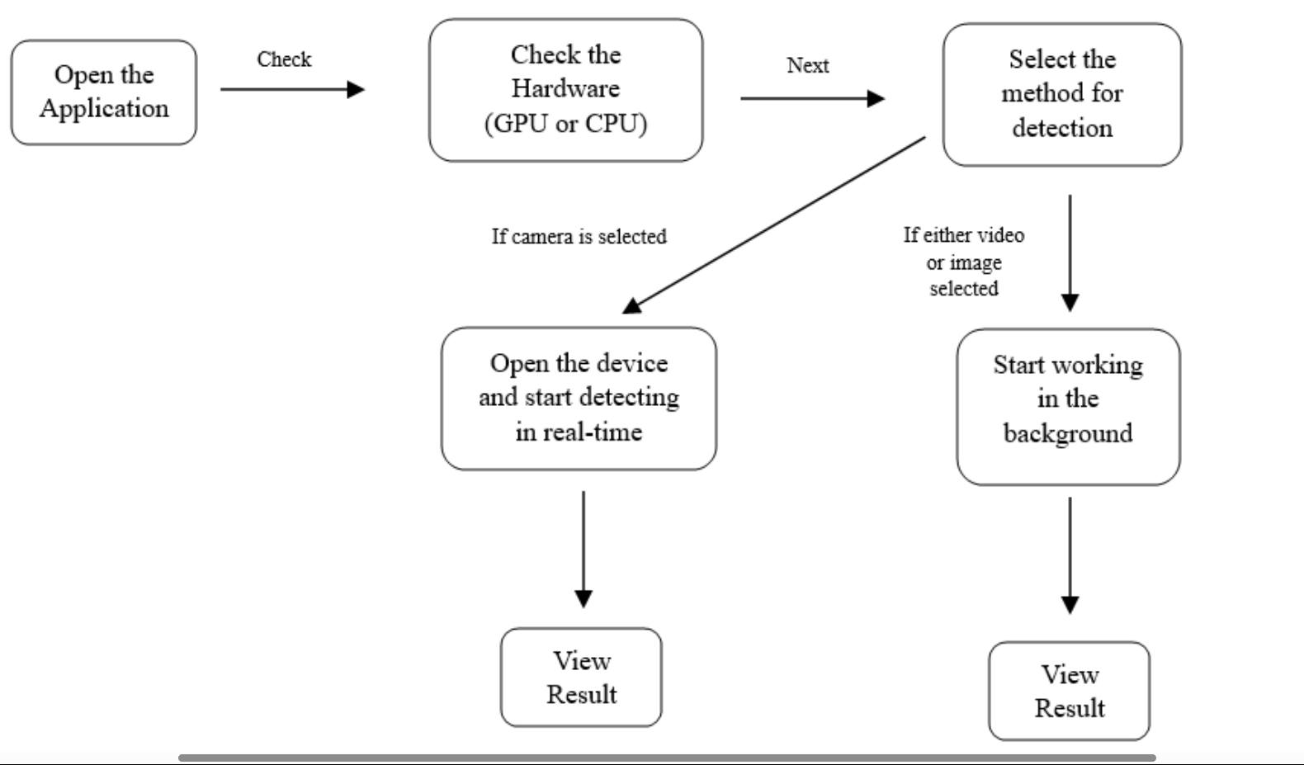
Fig 5-1 Application Pipeline diagram.

Acknowledgment
I would like to sincerely thank Ms. Kirti, my project supervisor, for her consistent guidance and encouragement throughout this work. Her feedback helped shape this project and gave me direction during the difficult parts.
I’m also grateful to the team behind open-source libraries like PyTorch, torchvision, and Google Colab for making development and testing more accessible. A big thanks to my teammates, even though the project went through a few hiccups, we got there in the end.
Lastly, I’d like to acknowledge the motivation and support I received from the broader machine learning community and my peers at Lovely Professional University. This project reflects my growing interest in applying ML for solving real-world problems.

Future Work
Going forward, several improvements can be made to enhance this project:

Model Training on Real Dataset: The next step is to fine-tune the ResNet18 model using a real road damage dataset like RDD2020 or an open-source municipal dataset. This will replace the current simulated predictions with real, learned outputs.
- Performance Optimization: Techniques like learning rate scheduling, data augmentation, and dropout regularization can be introduced during training to improve the model's generalization.
- Web/App Deployment: The current system runs on Google Colab, but it can be extended to a web or mobile application where users upload road images and get instant predictions.
- Class Expansion: Additional damage types can be introduced to broaden the system's use case in more varied urban environments.
- Geotagging Integration: For real-world deployment, adding GPS metadata can help map the damages geographically, turning the tool into a proper civic monitoring solution.
By addressing these areas, this project has the potential to evolve from a proof-of-concept to a fully operational system useful for public works and urban infrastructure planning.

Conclusion

In this project, we developed a lightweight road damage classification system using a modified ResNet18 model. The system demonstrates how deep learning can be used to automate infrastructure monitoring by classifying road surface issues into four categories: Alligator Crack, Lateral Crack, Longitudinal Crack, and Pothole.

Using a Google Colab interface, users can upload multiple real-world road images, which are then preprocessed and passed through the model to generate predictions. The results are visualized through annotated images, bar charts of class distribution, and evaluation metrics like confusion matrices and classification reports.

Although the current model outputs are simulated, the full pipeline is implemented and ready for integration with a trained model. This prototype lays the groundwork for a scalable road maintenance tool that could help municipal bodies prioritize repairs more efficiently.

XI. References

- D. Arya, H. Maeda, S. K. Ghosh, D. Toshniwal, and Y. Sekimoto, “RDD62: A multi-national image dataset for automatic road damage detection,” Data in Brief, vol. 47, p. 108853, 2023.
- D. Arya, H. Maeda, S. K. Ghosh, D. Toshniwal, H. Omata, T. Kashiyama, and Y. Sekimoto, “Global Road Damage Detection: State-of-the-art Solutions,” in Proc. IEEE Int. Conf. on Big Data, pp. 5533–5539, 2020.
- K. Doshi and Y. Yilmaz, “Road Damage Detection using Deep Ensemble Learning,” arXiv preprint arXiv:2111.00728, 2021
- H. Maeda, T. Kashiyama, Y. Sekimoto, T. Seto, and H. Omata, “Generative adversarial network for road damage detection,” Computer-Aided Civil and Infrastructure Engineering, vol. 36, no. 1, pp. 47–60, 2021.
- D. Arya et al., “Deep learning-based road damage detection and classification for multiple countries,” Automation in Construction, vol. 42, p. 103935, 2021.
- H. Zhang et al., “Improved YOLOv7 algorithm for floating waste detection based on GFPN and long-range attention,” Wuhan Univ. J. Nat. Sci., vol. 29, no. 4, pp. 338–349, 2024.
- Alfarrarjeh A et al. “Road Damage Detection using Deep Ensemble Learning,” arXiv preprint arXiv:2111.00728, 2021.
- Sulistyaningrum D R et al. Generative adversarial network for road damage detection,” Computer-Aided Civil and Infrastructure Engineering, vol. 36, no. 1, pp. 47–60, 2021.
[9] C.-Y. Wang, A. Bochkovskiy, and H.-Y. M. Liao, “YOLOv7: Trainable bag-of-freebies sets new state-of-the-art for real-time object detectors,” in Proc. CVPR, pp. 7464–7475, 2022.
[10] Ren et al. Model Taxonomy for Flood Fragility and Vulnerability Assessment of Buildings. International Journal of Disaster Risk Reduction. 53. 101985. 10.1016/j.ijdrr.2021 .
[11] Prasad D K's 623 Trainable bag-of-freebies sets new state-of-the-art for real-time object detectors,” in Proc. CVPR, pp.7899, 2022
[12] Galasso, Carmine & Pregnolato, Maria & Parisi, Fulvio. (2020). A Model Taxonomy for Flood Fragility and Vulnerability Assessment of Buildings. International Journal of Disaster Risk Reduction. 53. 101985. 10.1016/j.ijdrr.2020.101985.

